# EU Grants: Event description sheet (CE VR1e.f0. A–re0s1(2.00243.2)4072827009 - 10/07/2023

RV):

EVENT DESCRIPTION SHEET

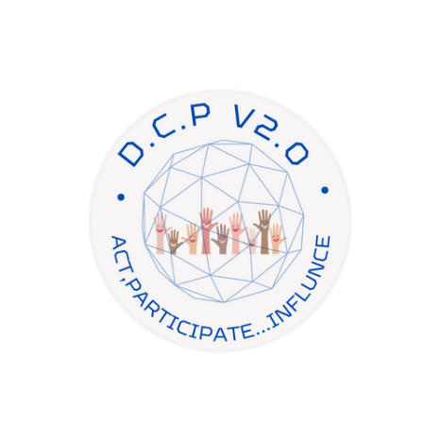

|  |  |
| --- | --- |
| **PROJECT** | |
| **Participant:** | [No 4] – Klaipedos Miesto Savivaldybes  Administracija |
| **PIC number:** | [930825678] |
| **Project name and acronym:** | [Digital Civic Participation v2.0] — [D.C.P v2.0] |

|  |  |  |  |
| --- | --- | --- | --- |
| **EVENT DESCRIPTION** | | | |
| **Event number:** | [WP10] | | |
| **Event name:** | Workshop for young people and municipal employees | | |
| **Type:** | Workshop | | |
| **In situ/online:** | In situ | | |
| **Location:** | Lithuania, Klaipeda – P. Komunos st. 16A  Lithuania, Klaipeda – Liepu 11 | | |
| **Date(s):** | 19.04.2023 | | |
| **Website(s) (if any):** | https://www.klaipeda.lt/lt/naujienos/naujienu-prenumerata/jaunimas/7671/skaitmeninio-pilietinio-dalyvavimo-dirbtuves:3989/ | | |
| **Participants** | | | |
| Female: | 35 | | |
| Male: | 9 | | |
| Non-binary: | 0 | | |
| From country 1 [Lithuania]: | 44 | | |
| From country 2 [name]: |  | | |
| From country 3 [name]: |  | | |
| … |  | | |
| Total number of participants: | 44 | From total number of countries: | 1 |
| **Description**  *Provide a short description of the event and its activities.* | | | |

|  |
| --- |
| The workshop activities aimed at educating, training, and empowering both young citizens and municipal employees on e-participation tools and concepts such as e-democracy and participatory approaches for local governance. These activities were designed to foster a greater understanding of the importance of citizen engagement in decision-making processes and to equip participants with the necessary skills and knowledge to actively participate in their communities.  Introduction to e-participation: The workshop began with an overview of e-participation, its significance in local governance, and its potential benefits for both citizens and municipalities. This session highlighted the importance of leveraging digital tools and platforms to promote inclusivity and engage a wider range of stakeholders.  During the workshop was presented real-life case studies and examples of successful e-participation initiatives from other municipalities or countries.  To identify common local issues and challenges, participants were divided into small groups. Each group was tasked with identifying a specific issue of concern and collaboratively brainstorming potential solutions using e-participation tools and approaches. This activity encouraged teamwork, creativity, and critical thinking, fostering a sense of ownership and responsibility among the participants.  During the workshop, young people said that measures relevant to young people should be publicized with the help of opinion makers and conditions should be created to easily find all relevant information by pressing a few buttons. Young people noticed that there is a need to make more use of social networks and spread more information about the work of the Youth Affairs Coordinator, the functions of the municipality, and the opportunities for young people.  The workshop activities aimed at educating, training municipal employees on e-participation tools and concepts such as e-democracy and participatory approaches for local governance. These activities were organized to foster a greater understanding of the importance of citizen engagement in decision-making processes.  Introduction to e-participation: The workshop began with an overview of e-participation, its significance in local governance, and its potential benefits for both citizens and municipalities. The workshop highlighted the importance of leveraging digital tools and platforms to promote inclusivity and engage a wider range of stakeholders.  During the workshop, we discussed the city participatory budget as one important e.participatory tool. Together with municipal employees, we talked about how to improve the participatory budget process through our electronic platform. |